Multipurpose Fielding Drill

Purpose
This drill practices 3 baseball fundamentals; fielding a ground ball, receiving a thrown ball, and backing up plays.
Suggested Age Level(s)
Rookie, Kid Pitch, Farm
Drill Setup
- Place 3 cones on the field in accordance with the below diagram. These cones signify the start of the line for each of the right field, 2nd baseman, and 1st baseman stations.
- Split the players into 3 groups and assign each group to a different station.

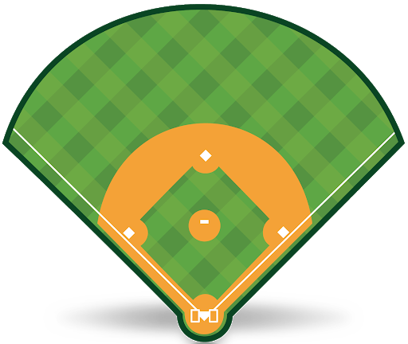

How It Works
- The first player at each station assumes the proper pre-pitch field position on the field.
- A ball is hit to the 2nd baseman. The 2nd baseman attacks the ground ball, fields and throws the ground ball to the 1st baseman with the proper mechanics. The 1st baseman attempts to catch the thrown ball. The player in right field backs up the throw to 1st base (i.e. runs to the fence behind 1st base).
- When the play is over, the player who was at 1st base goes to the back of the 2nd base station line, the player that was 2nd base goes to the back of the Right Field station line, and the player that was Right Field goes to the back of the 1st base station line.
Coaching Tips
- For younger levels, if appropriate, coaches can roll the ball to the 2nd base player instead of hitting it to them.
- There are several ways to modify this drill:
  - To practice longer throws to 1st base, move the 2nd base station to short stop or 3rd base.
  - To practice throws/plays to different bases, the 1st and right field stations can be moved (e.g. move the 1st base station to 3rd base and move the right field station to left field).
  - To promote attacking the ball during fielding, additional cones can be placed at the 2nd base station to signify a “gate” that the player has to advance through when fielding the ball (i.e. the player has to receive the ground ball after they proceed through the gate).

